Is Bilateral Trade Associated with Cross-Border Bank Claims?
Evidence from a Country-Pair Panel, 2015–2023
Research Paper
October 2026

Abstract
Cross-border bank lending is often assumed to follow trade, because banks finance and insure international transactions. This paper tests that idea using a bilateral panel that matches merchandise imports from UN Comtrade with cross-border bank claims from the BIS Locational Banking Statistics. The sample has 493 observations on 62 country pairs (seven claimant countries and ten counterparty economies) over 2015–2023. Across pairs, a 1% larger import flow is associated with 0.9–1.2% larger bank claims, and this holds before and after 2020. Within pairs over time the relationship is much weaker: the log-linear elasticity is 0.20 and statistically insignificant, a Poisson (PPML) specification gives 0.36 (p = 0.03), and a long-difference regression gives 0.45 (p = 0.27). I find no statistically significant differences between banking centres, emerging-market claimants and other advanced economies, nor between 2015–2019 and 2020–2023. The results indicate a strong structural link between trade and banking across country pairs, but little evidence that year-to-year changes in a pair’s trade are matched by changes in its bank claims. Tariff data, needed to extend the analysis to the effect of trade barriers, were not available for this draft.
Keywords: bilateral trade, cross-border banking, BIS locational banking statistics, gravity model, PPML, fixed effects

1. Introduction
Banks that operate across borders support international trade by providing trade credit, guarantees and payment services, and by serving the foreign operations of firms that export and import. This suggests that financial linkages between two countries should be larger where trade between them is larger. The idea also has a policy implication: if trade barriers such as tariffs reduce trade, they might indirectly weaken financial integration as well.
The original aim of this project was to test this full chain in two steps, first whether higher bilateral tariffs reduce imports, and second whether trade is associated with larger cross-border bank claims. The tariff data (World Bank WITS) were not available when this paper was completed, so the first step cannot be tested here. This paper therefore concentrates on the second step, which can be tested with the matched trade and banking data in hand, and extends it by examining whether the association is the same across types of claimant country and across time.
The central empirical issue is the difference between two kinds of variation. Country pairs that trade a lot tend to differ from other pairs in many ways (size, proximity, history, financial development), and these differences affect both trade and banking. A positive cross-sectional association may therefore reflect common structural factors rather than any link between the two flows. A more demanding test asks whether, within a given pair, claims rise when trade rises. The paper reports both and shows that the answer differs sharply between them.
Section 2 gives background and states the hypotheses. Section 3 describes the data and sample. Section 4 explains the empirical strategy. Section 5 reports the results, including heterogeneity and robustness checks. Section 6 discusses limitations, and Section 7 concludes.

2. Background and Hypotheses

2.1 Trade and cross-border finance
Bilateral trade is traditionally studied with the gravity model (Tinbergen, 1962), in which flows increase with the size of the two economies and decrease with the cost of trading. Anderson and van Wincoop (2003) showed that bilateral flows also depend on trade costs relative to all other partners, and Head and Mayer (2014) and Yotov et al. (2016) describe how country-time fixed effects handle this in practice. Santos Silva and Tenreyro (2006) showed that log-linearised gravity regressions can be inconsistent under heteroskedasticity and recommended Poisson pseudo-maximum likelihood (PPML), which I use as a check.
A related literature finds that financial linkages follow similar geography. Portes and Rey (2005) show that distance and information frictions shape cross-border equity flows in a way that resembles gravity, and Aviat and Coeurdacier (2007) study trade in goods and asset holdings jointly and emphasise that causality can run in both directions: trade creates demand for banking services, while banking presence can facilitate trade. For this reason the results below are interpreted as associations rather than causal effects.

2.2 Tariffs as motivation
Recent evidence shows that tariff increases reduce the affected import flows (Amiti, Redding and Weinstein, 2019; Fajgelbaum et al., 2020). If trade supports banking, a decline in trade caused by tariffs would be expected to reduce bank claims too. Testing that chain requires bilateral tariff data, which is left to future work (Section 7).

2.3 Hypotheses
- H1 (cross-section): Country pairs with larger bilateral imports hold larger cross-border bank claims (positive association).
- H2 (within pair): Within a given pair, years with higher imports are associated with higher bank claims. Because pair-level differences are removed, this is a stricter test than H1.
- H3 (heterogeneity): The trade–banking association differs by type of claimant country (banking centres, emerging markets, other advanced economies) and between the pre-2020 and post-2020 periods.

3. Data

3.1 Sources
- Imports (UN Comtrade). Annual total merchandise imports (all commodities, all modes of transport and customs procedures), reported by the importing country with the exporting country as partner, in current US dollars. The download covers 14 reporters and 10 partners (Argentina, Belgium, China, Indonesia, Poland, Saudi Arabia, South Africa, Spain, Sweden, Thailand) over 2014–2023, 1,400 observations with no missing cells. Rows for specific customs procedures were removed so that only the all-procedures total remains.
- Cross-border bank claims (BIS Locational Banking Statistics). Total cross-border claims of banks located in the reporting country, by residence of the counterparty, all instruments, currencies and sectors, as quarterly stocks in USD millions. The year-end (fourth-quarter) stock is used. The file covers seven reporting countries (Brazil, Canada, Chile, Mexico, Switzerland, the United Kingdom, the United States).

3.2 Matching and sample
A banking observation is the claim held by banks in claimant country i on residents of counterparty j at the end of year t. The matching trade variable is imports of country i from country j in year t. A pair-year is kept only when both series exist. Three features of the files determine the final sample:
- Only seven of the 14 Comtrade importers are BIS reporters in the downloaded file, so these seven are the claimants.
- The Comtrade download includes only ten partner countries, so claims on other BIS counterparties cannot be matched with imports.
- The BIS download omits 2014, and some series are suppressed by the BIS for confidentiality. The usable window is therefore 2015–2023 (nine years).
The matched sample has 493 observations on 62 country pairs (of 70 possible), with 53 to 57 pairs observed in each year. All claims are positive, so logarithms are defined, and no values were imputed.
Table 1. Summary statistics (matched sample, 2015–2023)
Variable | N | Mean | Std. dev. | Median | Maximum
Bank claims (USD m) | 493 | 7,736 | 15,189 | 1,258 | 103,771
Imports (USD m) | 493 | 20,729 | 69,308 | 3,704 | 575,688
ln(Bank claims) | 493 | 6.41 | 3.37 | 7.14 | 11.55
ln(Imports) | 493 | 8.44 | 1.61 | 8.22 | 13.26
Notes: Imports are imports of the claimant from the counterparty. Sources: BIS Locational Banking Statistics; UN Comtrade.
Table 2. Average claims and imports by claimant country
Claimant | Obs. | Mean claims (USD m) | Mean imports (USD m) | Claims / imports
Brazil | 53 | 1,176 | 10,294 | 0.11
Canada | 62 | 2,010 | 10,563 | 0.19
Chile | 56 | 592 | 4,107 | 0.14
Mexico | 52 | 291 | 16,644 | 0.02
Switzerland | 90 | 3,177 | 4,354 | 0.73
United Kingdom | 90 | 26,478 | 16,805 | 1.58
United States | 90 | 10,104 | 66,882 | 0.15
Notes: Claims/imports is the ratio of the two means. The high ratios for the United Kingdom and Switzerland reflect their role as international banking centres.
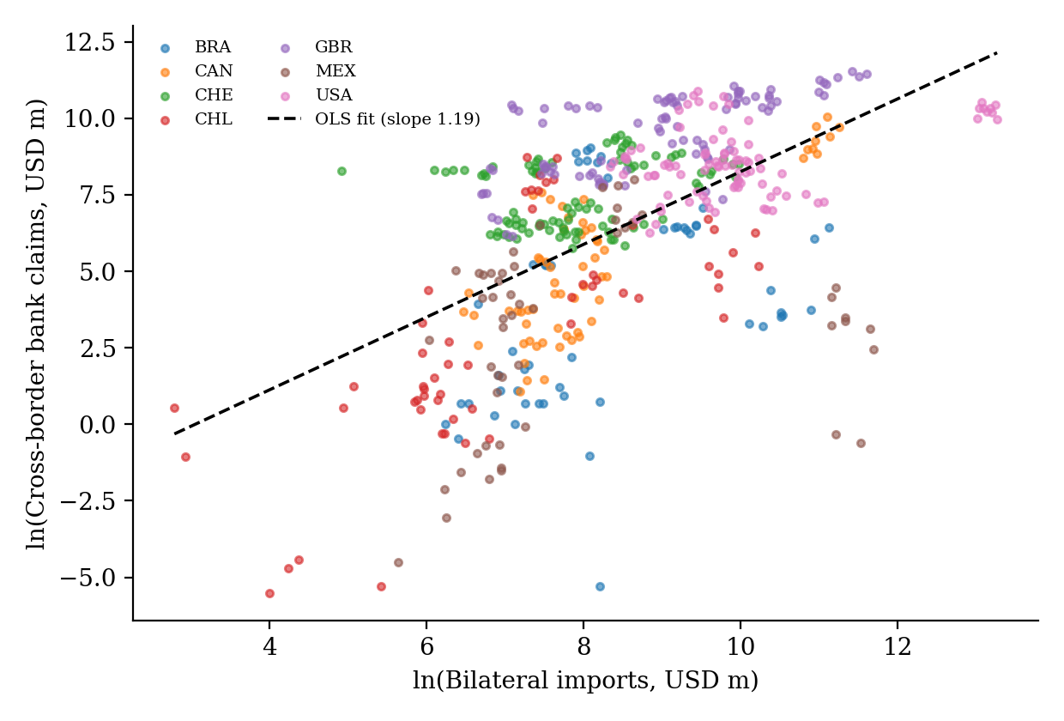
Figure 1. Bank claims and imports across country-pair-years (log scales).
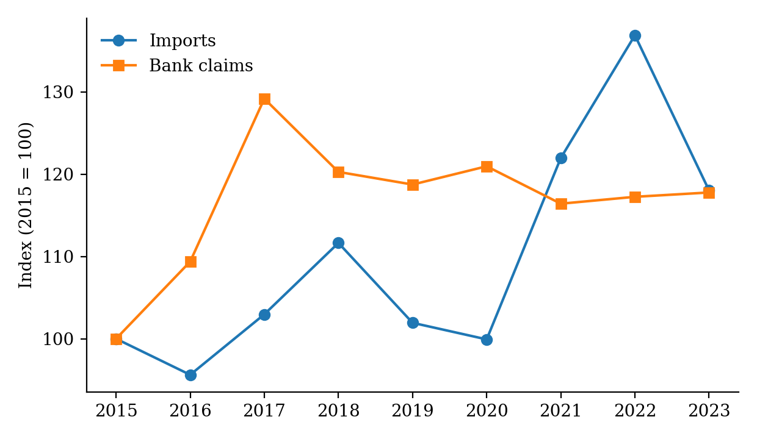
Figure 2. Aggregate imports and bank claims over time (2015 = 100), matched sample.
Figure 1 shows a clear positive cross-sectional relationship. Figure 2 shows that the aggregates move differently over time: imports dipped in 2016, peaked in 2022 (index 137) and fell back in 2023, while claims rose until 2017 (index 129) and then stayed between about 116 and 121. This divergence anticipates the weak within-pair result.

4. Empirical Strategy
The baseline equation is
ln(Claimsijt) = γ·ln(Importsijt) + controls + εijt
where i is the claimant country, j the counterparty and t the year. γ is an elasticity. H1 and H2 predict γ > 0 and are separated by the fixed effects used:
- M1: pooled OLS with year effects (uses both between-pair and within-pair variation).
- M2: adds claimant and counterparty effects, removing country-level differences such as being a banking centre. Identification still comes mainly from differences across pairs. This tests H1.
- M3: pair and year effects. Identification comes only from changes over time within a pair. This tests H2.
- M4: pair, claimant-year and counterparty-year effects (the most demanding specification).
- M5: as M3, with trade lagged one year to reduce simultaneity.
- M6: PPML with claims in levels and pair and year effects, which gives more weight to large pairs. Because analytic PPML standard errors can be too small in modest panels, a pairs bootstrap (300 draws) is also reported.
For H3, I add an interaction between ln(Imports) and an indicator for a claimant group (banking centre = UK or Switzerland; emerging = Brazil, Chile or Mexico) or for the post-2020 period (2020–2023). I also re-estimate the model separately by claimant group and by period. As an additional check I estimate a long-difference regression of the 2015–2023 change in ln(claims) on the 2015–2023 change in ln(imports), using pairs observed in both years. Standard errors are clustered by country pair (62 clusters). All coefficients are associations, not causal effects.

5. Results

5.1 Main results (H1 and H2)
Table 3. Bank claims and bilateral imports
Specification | γ (elasticity) | Cluster s.e. | p-value | N | R²
M1 Pooled OLS, year FE | 1.199*** | 0.252 | <0.001 | 493 | 0.33
M2 Claimant + counterparty + year FE | 0.899*** | 0.207 | <0.001 | 493 | 0.78
M3 Pair + year FE | 0.205 | 0.178 | 0.254 | 493 | 0.95
M4 Pair + claimant-year + counterparty-year FE | 0.106 | 0.259 | 0.683 | 493 | 0.96
M5 Pair + year FE, trade lagged one year | –0.036 | 0.270 | 0.894 | 424 | 0.95
M6 PPML, pair + year FE (claims in levels) | 0.357** | 0.158 | 0.027 | 493 | –
Notes: Dependent variable is ln(claims) in M1–M5 and claims in levels in M6. Standard errors clustered by country pair. ***, ** denote significance at 1% and 5%. For M6 the pairs-bootstrap standard error is 0.171 (p = 0.037; 95% percentile interval 0.06 to 0.75).
H1 is strongly supported. In the pooled model a 1% larger import flow is associated with 1.2% larger claims, and with claimant and counterparty effects the elasticity is still 0.90. The correlation between pair-average log claims and pair-average log imports is 0.63.
Support for H2 is weak. Once pair effects are included the elasticity drops to 0.20 and is not significant; it is 0.11 in M4 and approximately zero with lagged trade. The within-pair correlation of log claims and log imports is only 0.06. The long-difference regression, which compares each pair’s change between 2015 and 2023, gives a slope of 0.45 (standard error 0.40, p = 0.27, 50 pairs), which is positive but imprecise. Only PPML (M6) finds a significant within-pair elasticity (0.36, bootstrap p = 0.037), which suggests the link may be present among large pairs but cannot be detected for the average pair.

5.2 Heterogeneity (H3)
Table 4. Heterogeneity in the trade–claims association
 | Claimant + cp + year FE | p-value | Pair + year FE | p-value
Interaction: ln(imports) × banking centre | –0.473 | 0.152 | –0.360 | 0.264
Interaction: ln(imports) × emerging claimant | 0.187 | 0.580 | 0.051 | 0.925
Interaction: ln(imports) × post-2020 | 0.058 | 0.548 | 0.014 | 0.873
Split: banking centres (UK, CH), N = 180 | 0.264 | 0.105 | 0.111 | 0.180
Split: other advanced (CA, US), N = 152 | –0.852 | 0.129 | 0.317 | 0.266
Split: emerging (BR, CL, MX), N = 161 | –0.018 | 0.959 | 0.033 | 0.961
Split: 2015–2019, N = 270 | 0.850*** | <0.001 | 0.264 | 0.188
Split: 2020–2023, N = 223 | 0.987*** | 0.002 | 0.268 | 0.331
Notes: Interaction rows report the coefficient on the interaction term from a regression that also includes ln(imports). Split rows report the coefficient on ln(imports) in the sub-sample. Standard errors clustered by country pair. *** denotes significance at 1%.
None of the interaction terms is statistically significant, so H3 is not supported: there is no reliable evidence that the association differs between banking centres, emerging markets and other advanced economies, or between the periods before and after 2020. The sample splits show a similar picture. The cross-sectional elasticity is close to 0.85–0.99 in both periods, while the within-pair elasticity is about 0.26–0.27 and insignificant in both. The split by claimant should be read with care because each group contains only two or three claimants and 20–22 clusters, so the estimates are imprecise (for example the negative estimate for Canada and the US with claimant and counterparty effects).

5.3 Robustness
Table 5. Robustness of the elasticity
Check | γ | Cluster s.e. | p-value | N
Drop claims < USD 10m: pooled, year FE | 0.631 | 0.205 | 0.003 | 426
Drop claims < USD 10m: claimant + counterparty + year FE | 0.433 | 0.190 | 0.027 | 426
Drop claims < USD 10m: pair + year FE | 0.240 | 0.144 | 0.101 | 426
Exclude 2020: pair + year FE | 0.182 | 0.206 | 0.381 | 437
PPML with claimant + counterparty + year FE | 0.193 | 0.123 | 0.121 | 493
Notes: Standard errors clustered by country pair.
Trimming very small claims lowers the cross-sectional elasticity to 0.43–0.63, so part of the baseline estimate comes from small, noisily measured claims, but it stays positive and significant. The within-pair estimates remain positive and insignificant, and PPML with claimant and counterparty effects is also insignificant. The PPML pair-effects result in Table 3 is therefore the only specification that finds a significant within-pair association.

6. Limitations
- Small sample. Seven claimants and ten counterparties are used, including two major banking centres, so results may not generalise.
- Directional trade. The trade variable is the claimant’s imports. Total bilateral trade (imports plus exports) would be more complete.
- Causality. Banking relationships may promote trade, and common shocks may move both. The results are associations.
- Time window. The banking data omit 2014, so nine years are used instead of ten.
- Measurement. Claims are dollar stocks affected by exchange rates and valuation changes, while imports are flows. Fixed effects only partly absorb this.
- Power. With 62 clusters and limited within-pair variation, the within-pair estimates are imprecise. Insignificant results do not prove that no link exists.
- Tariffs. The effect of tariffs on trade, and indirectly on banking, is not tested here.

7. Conclusion and Future Work
This paper examined whether bilateral trade is associated with cross-border bank claims. Across country pairs the association is strong and stable: pairs that import more also hold much larger claims, with elasticities close to one, before and after 2020 and across claimant types. Within a pair over time the association is weak. It is insignificant in log-linear models with pair effects, imprecisely positive in a long-difference regression, and significant only in a PPML specification that emphasises large pairs. The evidence therefore supports a structural link between trade and banking but does not support the claim that short-run changes in trade quickly move bank claims.
Future work should add bilateral tariff data (WITS) to test whether tariffs reduce imports and, through that channel, claims; extend the banking panel to include 2014 and more claimant countries; and use total bilateral trade. A gravity specification with tariffs, importer-year and exporter-year effects and PPML is already prepared for this purpose.

References
Amiti, M., Redding, S. J., and Weinstein, D. E. (2019). The impact of the 2018 tariffs on prices and welfare. Journal of Economic Perspectives, 33(4), 187–210.
Anderson, J. E., and van Wincoop, E. (2003). Gravity with gravitas: A solution to the border puzzle. American Economic Review, 93(1), 170–192.
Aviat, A., and Coeurdacier, N. (2007). The geography of trade in goods and asset holdings. Journal of International Economics, 71(1), 22–51.
Cameron, A. C., Gelbach, J. B., and Miller, D. L. (2008). Bootstrap-based improvements for inference with clustered errors. Review of Economics and Statistics, 90(3), 414–427.
Fajgelbaum, P. D., Goldberg, P. K., Kennedy, P. J., and Khandelwal, A. K. (2020). The return to protectionism. Quarterly Journal of Economics, 135(1), 1–55.
Head, K., and Mayer, T. (2014). Gravity equations: Workhorse, toolkit, and cookbook. In G. Gopinath, E. Helpman and K. Rogoff (Eds.), Handbook of International Economics, Vol. 4, 131–195. Elsevier.
Portes, R., and Rey, H. (2005). The determinants of cross-border equity flows. Journal of International Economics, 65(2), 269–296.
Santos Silva, J. M. C., and Tenreyro, S. (2006). The log of gravity. Review of Economics and Statistics, 88(4), 641–658.
Tinbergen, J. (1962). Shaping the World Economy: Suggestions for an International Economic Policy. New York: Twentieth Century Fund.
Yotov, Y. V., Piermartini, R., Monteiro, J.-A., and Larch, M. (2016). An Advanced Guide to Trade Policy Analysis: The Structural Gravity Model. Geneva: World Trade Organization.

Data sources
UN Comtrade database (annual merchandise imports, total, 2014–2023); Bank for International Settlements, Locational Banking Statistics (cross-border claims by residence, year-end stocks).

